**FPGA Karaoke**

A Final Report for ECE383

By

C2C Mark A. Demore II

May 4, 2018

**PROJECT PROPOSAL**

1. **Objective**:

The purpose of this system is to take an audio input and strip out the vocals, display an FFT of the audio and output it through a speaker, along with input from a microphone. Some additional functionality may be to match microphone input with the stripped vocals to measure accuracy.

1. **Technical Requirements:**

The voice stripper must remove all main vocals or reduce main vocals to a negligible level in comparison to instrumentals (Basic Functionality). The FFT must display the full range of the input audio (B-Functionality). Switches will turn voice stripping and the microphone source on and off (A-Functionality).

1. **Top Level Design:**

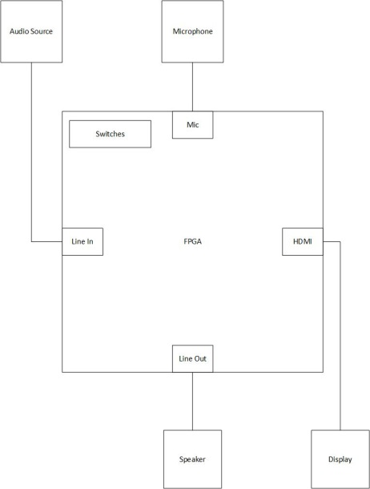

|  |  |
| --- | --- |
| Module | Nexys Video FPGA |
| Inputs | On-board switches, audio source via aux Line In, Microphone |
| Outputs | Display via HDMI, Speaker via aux Line Out |
| Behavior | Voice stripping, audio FFT display, switches used to modify audio out to include enable/disable voice stripping and microphone audio |

**PROJECT PLAN**

1. **Level-1 Design**:

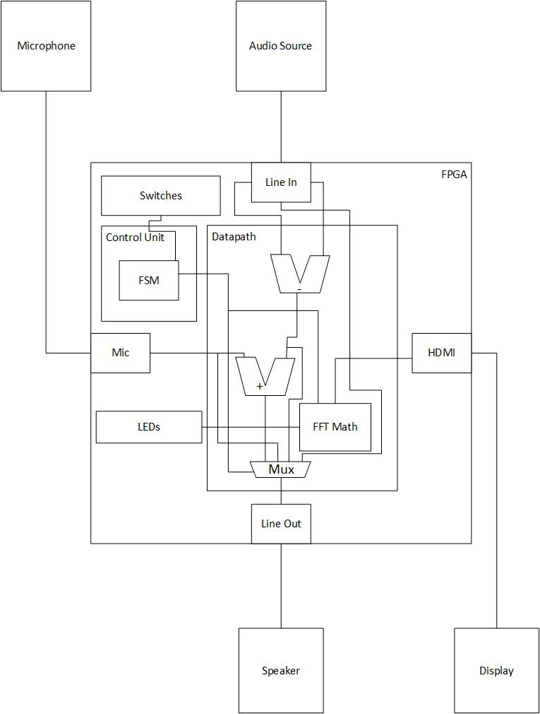

Control Unit FSM:

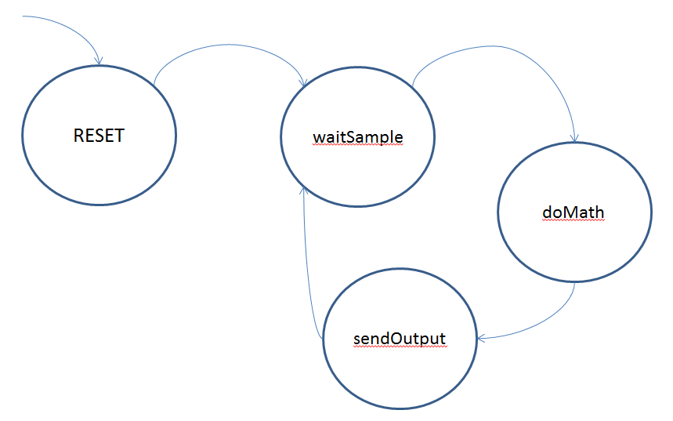

1. **Calculations:**

DC Sorting: $\frac{1024 samples}{6 bins} ≈170 samples/bin$

Bins: $\frac{Sum of Inputs}{Bin \# × 170}=Output Value$

1. **Bill of Materials:**

* Nexys Video FPGA
* Microphone
* Speaker
* Monitor
* Audio Source (phone)

1. **Milestone I:**

Implement voice-stripping. Use a subtractor between the right and left channels to remove the vocals from audio input and output it via the speaker. This will have to be verified by ear.

1. **Milestone II:**

Implement switches and microphone input. Switches will determine which audio to output: with or without voice-stripping and with or without microphone input. A test-bench can be used to verify this functionality, as well as complete implementation on the board, verified through the speaker by ear.

1. **Functionality:**

**Basic –** Complete Milestones I and II

**B –** Implement FFT calculations and basic display on LEDs

**A –** Implement an FFT plot capable of displaying the full range of input on the display via HDMI

FFT will be extensively tested in a test-bench. All will be verified by performance on the FPGA and documented via video.

**FUNCTIONALITY**

1. **Milestone I:**

As discussed in the project plan, Milestone I was to implement voice stripping, which was verified by ear. Jimmy Buffet's Margaritaville was used as the baseline, with other songs working better or worse depending on their recording method.

1. **Milestone II:**

Milestone II was altered from the project plan. The switch, alternating between original audio and voice-stripped audio was easily implemented and also verified by ear. However, enabling the microphone on the Nexys Video board proved to be much more challenging with the I2C Audio Codec, and was not implemented.

1. **Final Functionality:**

Final Functionality was also altered. With the difficulty of implementing a true FFT plot, a shifting DC plot was implemented with 6 "bins". The plot also changes colors any time the middle bin exceeds 50% of its maximum value. Given the unexplained failure of simulation in Vivado with the addition of the switch input, this was verified by sight. All audio processing was done in real time, as represented in the FSM and Level-1 Design.

NOTE: See ReadMe file for dates of accomplished objectives.

Final FSM:

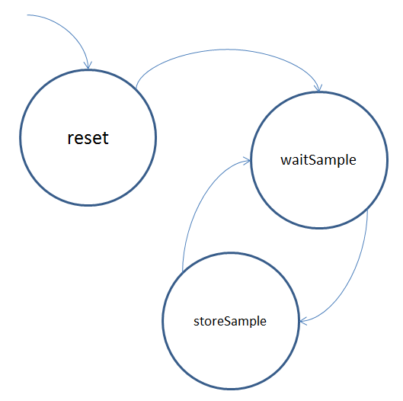

Final Level-1 Design:

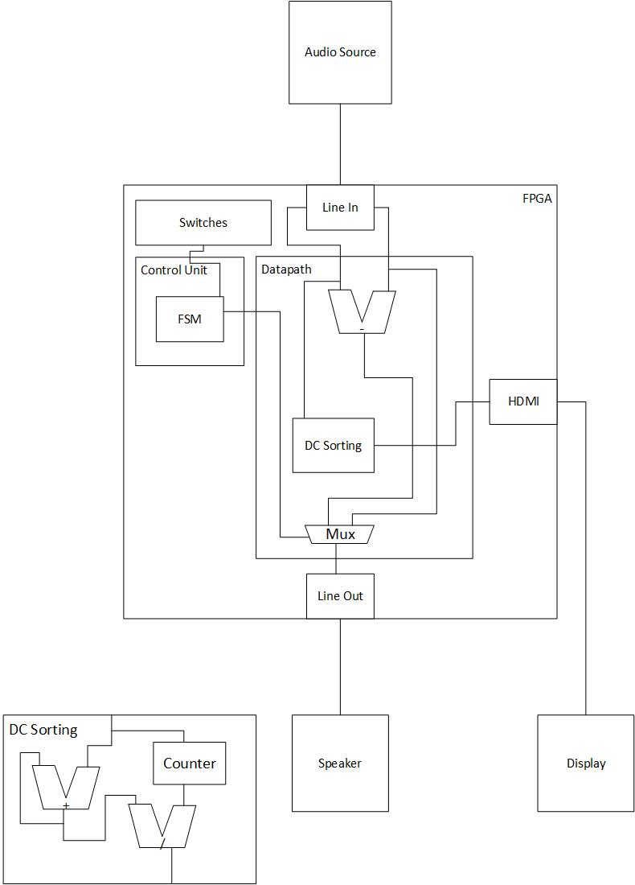

**APPENDIX A: Running the Project**

In order to run the project, simply load the bit file on to the Nexys Video board. Connect a display with the HDMI OUT port, and a speaker with the LINE OUT port. Plug a phone, iPod, MP3 Player or other device in to the LINE IN port using an AUX cord and begin playing a song on the device. Use SW0 on the board to turn voice-stripping on and off. Enjoy!